Task 6

1. Chat GPT

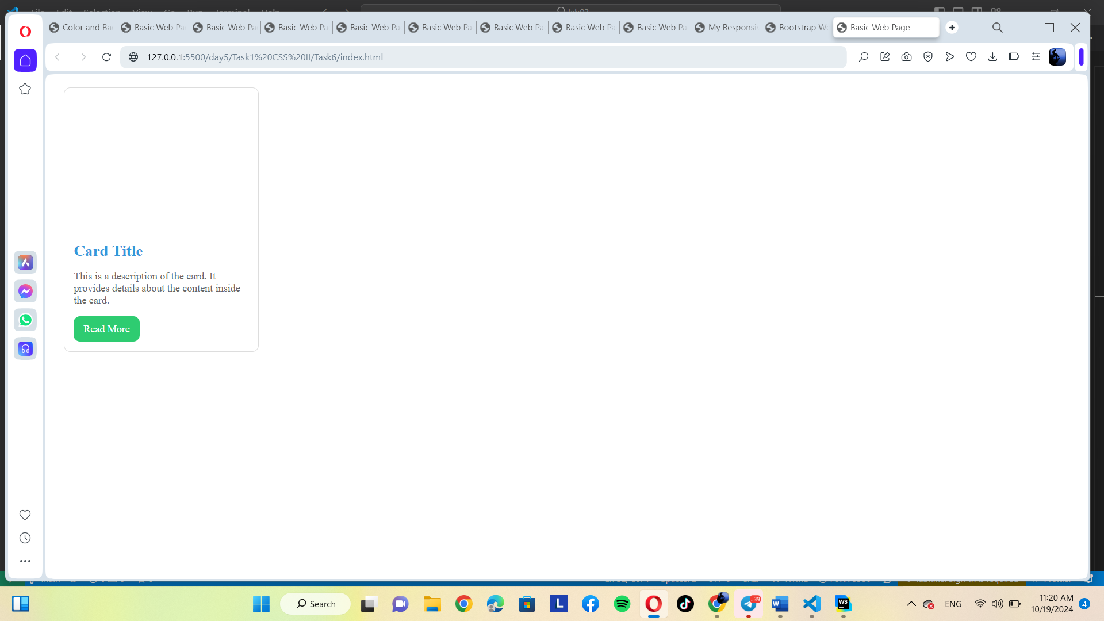

2. Gemini doesn’t match with HTML